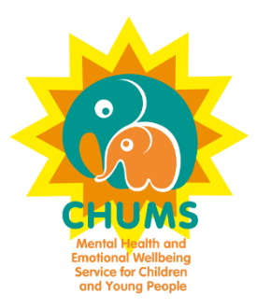Wrest Park Enterprise Centre

Wrest Park, Silsoe

Bedfordshire

MK45 4HS

23 January 2018

Dear Parents and Carers,

**Childrens Mental Health Awareness Week 5th – 11th February 2018 Non-Uniform Day**

**<insert school name>** is proud to support CHUMS during Children’s Mental Health Week 2018.

Many Children go through tough times just like adults and the smallest act of kindness and learning to be yourself can make a big difference. Please join us in helping to promote positive mental health alongside many local schools across Bedfordshire.

In the week before February half term CHUMS will launch: Shine Bright, Wear Bright. We invite all the students (and teachers!) to wear bright coloured clothes and donate £1 for a designated dress down day on **Friday 9th February 2018** to ‘spread a little kindness’ and ‘be yourself’.

Also attached is information on an artwork and/or poem competition CHUMS is running, open to all school aged students across Bedfordshire.

CHUMS provides Mental Health and Emotional Wellbeing Services to over 3,150 children and young people from Luton and Bedfordshire every year. The children we meet need specialist support to help with anxiety, increase self–esteem and build resilience. With your support, our experienced clinicians are able to provide the right support, at the right time, for each individual child - allowing them to go forward and reach their full potential.

* **1 in 10 children have a diagnosable mental health disorder – that’s roughly 3 children in every classroom**
* **1 in 5 young adults have a diagnosable mental health disorder**
* **Half of all mental health problems manifest by the age of 14, with 75% by age 24**
* **Almost 1 in 4 children and young people show some evidence of mental ill health (including anxiety and depression)**
* **Suicide is the most common cause of death for boys aged between 5-19 years, and the second most common for girls of this age**
* **1 in 12 young people self-harm at some point in their lives, though there is evidence that this could be a lot higher. Girls are more likely to self-harm than boys**

If you would like more information please contact the school office or see the CHUMS website www.chums.uk.com for more ways you can fundraise and support CHUMS.

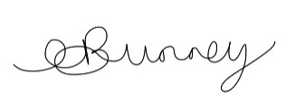Kind regards



Anna Bunney & Nicky Perry

Community Fundraising Managers

**01525 863924**

Email: [anna.bunney@chums.uk.com](mailto:anna.bunney@chums.uk.com)



**COMPETITION**

SHINE BRIGHT, WEAR BRIGHT

CHILDREN’S MENTAL HEALTH WEEK 5th- 11th FEBRUARY 2018.

Design a picture or a poem with any of the themes

SPREAD A LITTLE KINDNESS, BE YOURSELF AND SHINE BRIGHT.

There will be three age groups (7 and under, 8-12 and 13+). We will have Prizes for the winners and your artwork or poem maybe displayed in our offices and in our publications/website. Please feel free to decorate your poem too. **Closing date 30th March 2018.**

Please attach this sheet with a paperclip to your artwork or poem clearly stating your name, age and school on the rear and complete the below details:

Name:_________________________________________________Age:_________________

School:_____________________________________________________________________

Parents/Carers name:______________________________________________________________________

Contact email and telephone number:____________________________________________________________________

By entering the competition you agree to your artwork or poem being on display at CHUMS and in our publications/website.

Please post your artwork or poem to:

Anna Bunney – Community and Events Fundraising Manager

Wrest Park Enterprise Centre, Wrest Park, Silsoe, Beds, MK45 4HS.

Poems can be posted or emailed to: [anna.bunney@chums.uk.com](mailto:anna.bunney@chums.uk.com)

For more information please email Anna above or ring 01525 863944

