KCL Application Guidance

Postgraduate Certificate in Child and Young Persons Psychological Wellbeing Practice

All applicants to the Children’s Wellbeing Practice Programme will be required to undertake Postgraduate Certificate level training at Kings College London alongside a work placement.

Please note that you will need to submit an application form to Kings College London for a place on the Postgraduate Certificate in Child and Young Persons Psychological Wellbeing Practice in addition to the job application that you make to the relevant Service.

On successful entry to the programme, all trainees will be required to attend teaching for up to three days per week. The programme is delivered in conjunction with the Anna Freud Centre where most of the teaching and lectures will be based at Kings College London Campus in Denmark Hill. Students will be taught using a combination of lecture style workshops and small group seminars. Assessment on the programme will comprise of a combination or written, oral and video assessments. On successful completion of the course, students will graduate with a Postgraduate Certificate in Child and Young Persons Psychological Wellbeing Practice.

Entrance Criteria

Applications to the programme will be reviewed against the following criteria:

- A minimum of a second-class Bachelor's degree from a UK university or an overseas qualification of an equivalent standard in a relevant subject (e.g. psychology)
- Motivation to undertake and complete the course
- If your education has not been conducted in the English language, you will be expected to demonstrate evidence of an adequate level of English proficiency. Further information can be found on our English language requirements page at http://www.ucl.ac.uk/prospective-students/graduate/life/international/english-requirements. The English language requirement for this programme is: Good

Please note that applications will not be considered from applicants who are formally registered (or re-sitting examinations) for another programme of study at KCL or any other Higher Education Institution.

Making an application

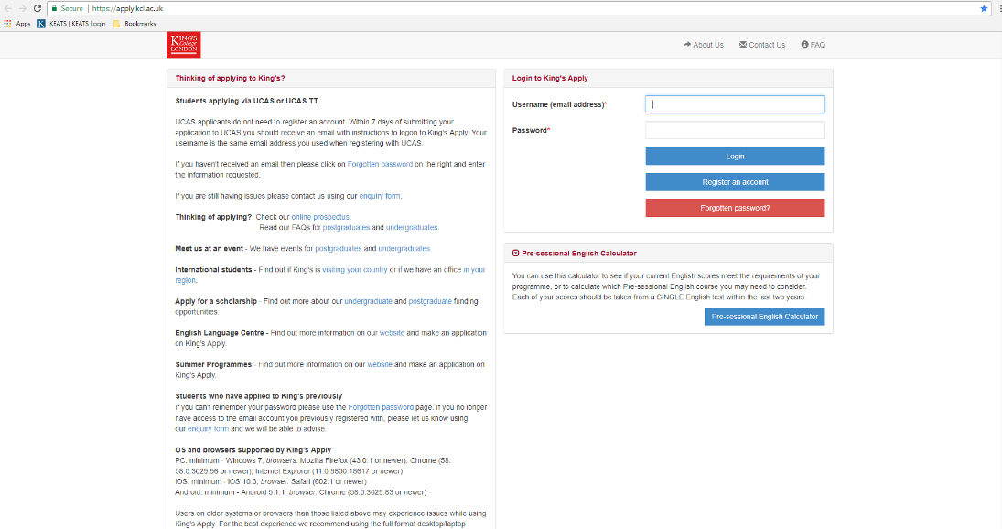
Please click on the following link to apply to KCL online: https://apply.kcl.ac.uk/

You will need to register an account and login to create a new application.

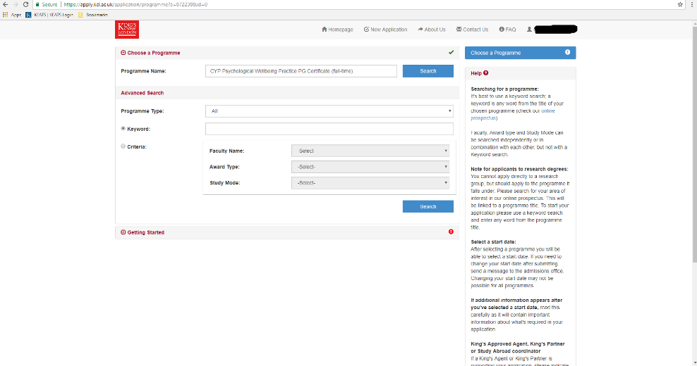
Click on ‘New Application’ in the menu bar at the top of the screen. You should then search for CYP Psychological Wellbeing Practice PG Certificate (full-time). As you type, a drop-down menu will appear - click on the relevant option.

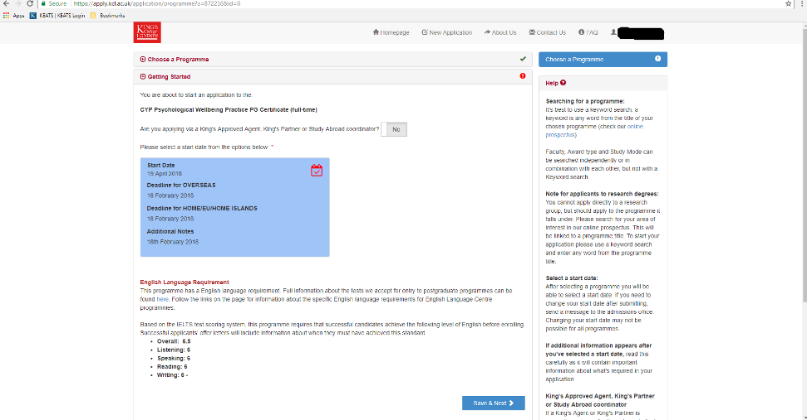
This will take you to a screen asking you to select a start date - you will need to click on the checkbox selecting April start month and click Save. (This window also asks whether you are applying via a King's Approved Agent, King's Partner or Study Abroad coordinator - the default answer No ought to be selected.)

The application form requires that you identify the source of funding for your study. Please select 6. Other; Organisation Name should be ‘Health Education England' and Organisation Type should be ‘Public body'.
For guidance on completing the online application please visit:
http://www.kcl.ac.uk/study/pg/admissions/TaughtProgrammes.aspx

Answers to Frequently Asked Questions can be found at:
http://www.kcl.ac.uk/study/postgraduate/apply/faqs.aspx

Personal Statement
As part of your online application, we would like you to write a personal statement of up to 1000 words.
- Please include:
  - Your name
  - The service that you are applying to alongside this application
- Why you would like to do this course?
  - Personal motivation
  - Career relevance
- Describe any relevant experience you have in the field.
- How would you cope with the academic demands of the course?

Interviews
Upon submission of your two applications, your job application will be considered and you will be informed of whether you have secured an interview. The interview will consist of questions from the service and from the University and the final decision on your application will be made by the employer and the university in collaboration.

Further Queries
If you have any queries regarding your online application, please contact the KCL admissions office (020 7848 1659)

If you have any queries relating to the programme, please contact the KCL CYP IAPT office:

Email: cyp-iapt@kcl.ac.uk
Telephone: 020 7848 5096

