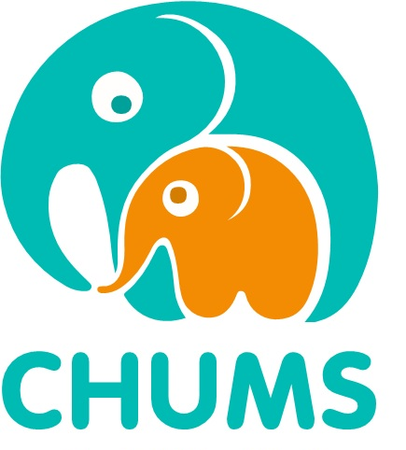
Volunteer Information and
Application Form

Introduction
The purpose of this document is to give you a clearer understanding of our work and the skills needed to become one of our volunteers. Included in this document is an application form for you to complete and return to us if you felt you would like to proceed further with your application. Once this has been received, we will invite you for an informal meeting. All our volunteers must complete a brief health questionnaire, provide two references and have a DBS check.

About CHUM S
CHUMS is a Social Enterprise, which is a community interest company, whose profits are reinvested into the service for the good of those we support. Our services offer several voluntary opportunities. Our volunteers are all committed to making a difference to the lives of children, young people and their families. The work is very rewarding and can make a big difference to those we support.

We support our volunteers by offering a regular ongoing training programme and a monthly communications meeting. All our volunteers are offered support and supervision. Social activities are also organised throughout the year.

Commitment
We understand that most of our volunteers have many other commitments, so we do not ask you to do regular weekly/hourly sessions, but rather fit your time around your work/life balance. We would like you to attend regular support sessions and training evenings, so you can meet the team and other volunteers. You can choose to work in just one area, or in several areas of our service. It is desirable that volunteers should have some experience of working with children and/or young people and families.

Volunteer Opportunities

- Supporting all our services - additional training is required for bereavement support.
- Driving - children and/or parents/carers to 1:1 sessions or workshops.
- Fundraising - A variety of events across the year.
- Assisting at workshops / programmes offering support to children and young people or their parents/carers:
    - Emotional Wellbeing Service Workshops - Anxiety, ASD, Low Mood and Resiliency.
    - Recreational Service - Sports, music and art.
    - Young Carers - working with Young Carers and their families.
    - Bereavement Support - additional training required, assisting at workshops, Babyloss Service, Bedfordshire Suicide Bereavement Service (BSBS) and ongoing group work.
    - Mentoring - supporting children and young people in their school environment.

Please Note: Some additional training may need to be undertaken to support some of these programmes.

CHUMS Volunteer Application Form

Please complete in BLOCK CAPITALS.

First Name: Surname:
Other Names: Date of Birth:

Address:

Postcode:
Telephone Numbers
Home: Mobile:
Email Address:
Ethnicity: Do you hold a current driving license? (Y/N)
If so, do you have use of a car? (Y/N)
Occupation(s)/Previous Occupation(s):

Please give the reason why you are interested in working with children and young people:
Which areas of our service are you hoping to support?

Please give details of any previous work experience with children and young people:

Please describe what experiences have been important to you:

Have you had any major personal loss within the last two years?
(e.g. bereavement, divorce, redundancy). If yes, please give brief details:

Please give details of any relevant training or qualifications you have:

What days/times are you available to offer your support?

Any other relevant information you think might be useful?

Do you give CHUMS permission to retain your personal information on file for General Data Protection Regulation? Y/N

Please give the name, email, and telephone number of two referees who we can contact for a reference, one of which must be a professional.
1)

2)

Please return the completed form to: volunteers@chums.uk.com
Or return by post to:
Volunteer Coordinator
Chums
Wrest Park Enterprise Centre
Wrest Park
Silsoe Beds
MK45 4HS

Telephone: 01525 863924

